We Transport!  We have a fleet a vans that CPM uses to transport individuals to and from Day Programs. Just ask a Program Coordinator to see if we are able to reach you! We will do our best.  Hours of Operations  CPM day programs run from Monday through Friday 8am to 3pm each day.  Locations in CT  Shelton  549 Howe Ave Shelton, CT 06484  (203)339-2595  Waterbury  579 Wolcott St Waterbury, CT 06705  (425) 233-2108  Manchester  75 Summit St, Manchester, CT 06040  (860)643-0355 |  | What Makes Us Different?  There may be times throughout care coordination of your loved one, where you feel boxed in by the norm. Cultivating Personal Milestones is not looking to fit square pegs into round hole per se. We are looking to create programs that best fit the needs of each individual. If you have had an idea about what could be beneficial to a person and/or loved one in which you provide care, we will try our best to accommodate the idea. Some say why, we say Why Not? |  | 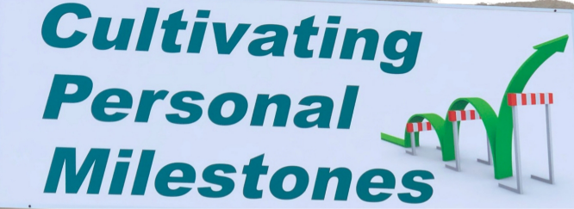
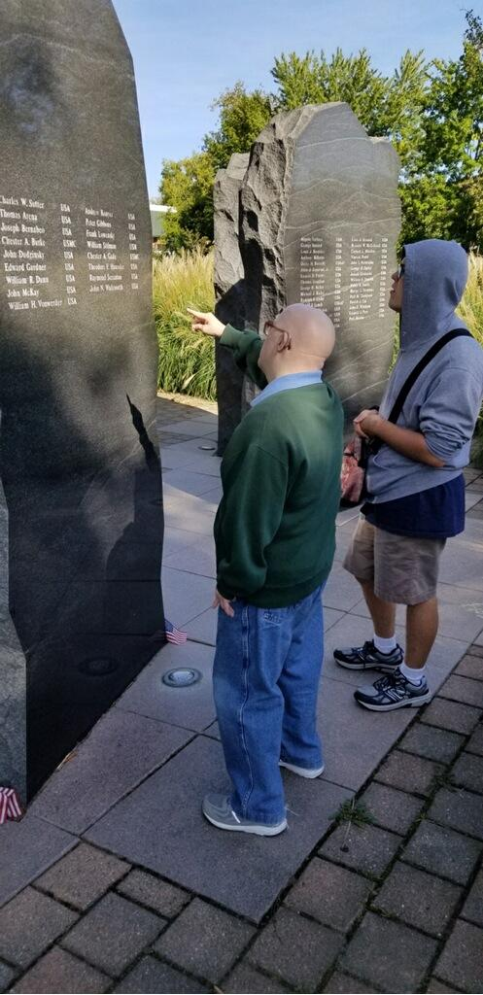
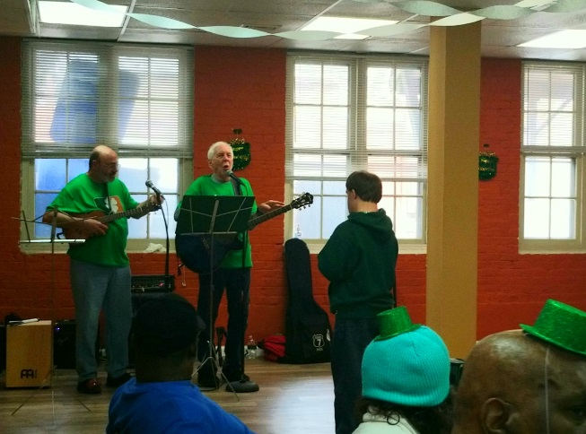
 |  |  |  | CPM

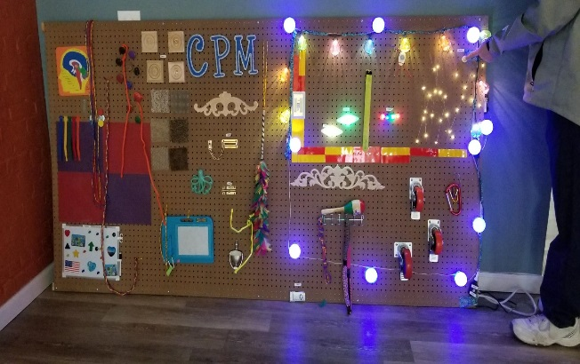 |  | Day Support Options  Day Support Options to encourage individual’s social inclusion and individual growth. Each program shares common goals to sharpen ADL’s, acquire emotion regulation, develop self-esteem, maintain self-worth, and integration into the community through volunteering.  DSO Structured Groups  Currently CPM offers a gamut of structured groups such as Culinary, Kitchen Safety, Art Therapy, Sensory, Community Experience, Music Therapy, Career Planning, Thrift Store, Skills Training and Exercise, Wellness. |  | “It does not matter how slowly you go as long as you do not stop”  -Confucius
Who We Are  Started in 1980, Cultivating Personal Milestones (CPM) operates programs that enable people living with disabilities to remain in the community; supporting their capacities to lead productive lives surrounded by friends and family rather than in institutionalized settings.  Cultivating Personal Milestones day programs seek to find innovative solutions to such social issues as joblessness, illiteracy, and stigma surrounding this demographic. Each CPM program is based on the belief that self-esteem and personal dignity start with an ability to become self-sufficient.  CPM has always operated with a goal of helping the individuals served by its programs attain their fullest personal and economic potential regardless of the severity of the barriers they may face. The agency’s approach is to increase social and work competence, provide opportunities for participation in the greater community and develop those opportunities for all of its participants. |  |  |  | Group Supported Employment  CPM offers the individuals enrolled in the GSE program personal case management to find solutions to common barriers concerning work and paid on-the-job training through work site experience.  CPM prides itself on keep the individual to staff ratio low, so that each individual maintains and progresses in acquiring skills for competitive employment.  Our Jobs  - Magazine Delivery  - Lawn Care  - Junk Removal  - Janitorial Services  - Small Equipment Maintenance  - Painting Exterior/Interior  - Volunteer Human Services
 |  | 